Technical Design Document

Download Selected Workflow Items(s) from Workflow App List

Table of Contents

Technical Story 1.1: create the api method to allow the download of multiple workflow items/documents. 2

CLIENT SIDE CHANGES 2

Technical Story 2.1: Download workflow item button shouldn’t be visible to the user if user isn’t View rights on the workflow 2

Technical Story 2.2: Download Button Enable/Disable on Workflow Item Selection 3

Technical Story 2.3: Downloading the content 3

Technical Story 2.4: Naming Convention for downloaded file 3

MOCK UP: 4

QA Notes: 4

Download Option in Workflow App List’s Toolbar *This document provide technical aspect of implementing download of workflow item content from workflow list app.*

[*FD_Download Selected Workflow Items from Workflow App List*](https://operations.cloud.papersave.com/PaperSave.WebModule/DocumentDisplay.aspx?DocIDs=260605)

## Technical Story 1.1: create the api method to allow the download of multiple workflow items/documents.

* Action: POST
* Route: api/documents/downloadcontent/layers/{true/false}
* Return Type: ActionResult
* Body: [1,2,3] (Array of Document Ids) (We’ll always pass document id)
* Response:

Should return the file to download.

* Following business rule validation should be done before content for a document can be downloaded successfully.
  + If the Document ID is of Workflow Item
    - Check User has view rights
    - Check User is Workflow Admin
    - Check User is Super user.
    - If any of this condition is true, it is ok to return the content.
  + If the Document Id is of Document
    - Check User has view rights on Document Type
* If any of the security validation fails, then that document should be skipped from the list.
* If security validation is successful then if only single file is requested we should return it using following.

return File(bytearray, System.Net.Mime.MediaTypeNames.Application.Octet, "{FileName} ");

* Else we should create the zip file and return it.
* Refer to the “DownloadFile.ashx.cs” code for creation of the zip.
* File Naming should be as per the functional document.

### CLIENT SIDE CHANGES

Technical Story 2.1: Download workflow item button shouldn’t be visible to the user if user isn’t View rights on the workflow

* Workflow Response object already has the different property set. One of the property is “HasViewPrinciples”.
* So, when a workflow is selected, we can know client side whether the user is authorized to view an item or not.
* If user isn’t authorized to view then we should not show the download button at all. We can bind the model of the button with this “HasViewPrinciples”.
* If the user is authorized to view then we should show the button.

Technical Story 2.2: Download Button Enable/Disable on Workflow Item Selection

* When user has view rights, we should show the button in the action panel. (Disabled)
* When any item is selected, we must be maintain a list of selected items.
* The enable/disable of the download button in the action panel should be bind to the count of the item in the list of selected item.
* So enable/disable of the delete button will work properly based whether the item is selected or not.

Technical Story 2.3: Downloading the content

* When download button is clicked, it should call the above API and pass necessary parameters.
* This should be asynchronous call.
* The result of this call will start the download of the content.

Technical Story 2.4: Naming Convention for downloaded file

* When a single file is downloaded then the filename pattern should be as following.
  + WORKFLOWITEMID + “- “ + CURRENT DATE AND TIME (DateTime.Now.ToString("yyyyMMddHHmmssff"))
* When multiple files are downloaded then the filename pattern should be as following
  + The name of the zip file should be “Workflow items of “ + WORKFLOWNAME + “ workflow - “ + CURRENT DATE AND TIME. (Please make sure to remove any special character from workflow name that isn’t allowed in filename.)
  + Each workflow item’s name within the zip file should have the below naming convention:

WORKFLOWITEMID + “ - “ + CURRENT DATE AND TIME

MOCK UP:

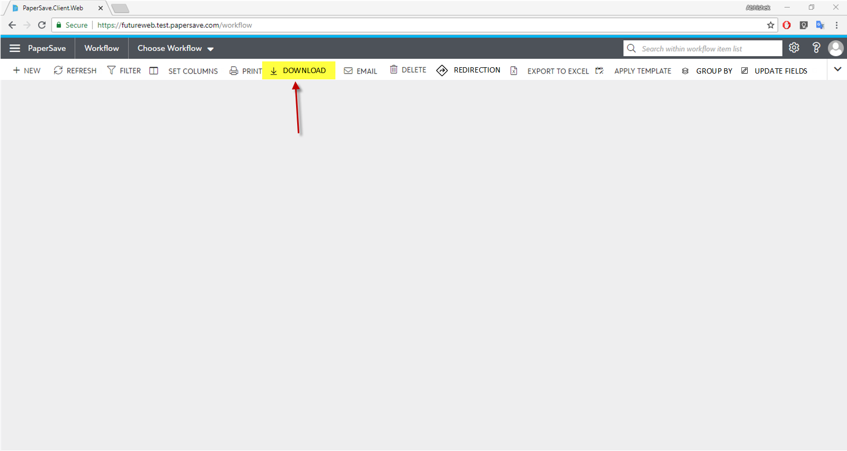

QA Notes:

* We won’t be showing any notification for download at the moment. There is a technical limitation at the moment.
* Test the download of password protected pdf files.
* Audit log isn’t implemented.